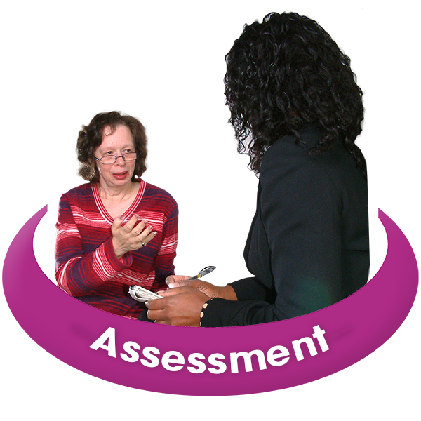



**Working out if you need to pay for your care and support**

Easy Read Version of

**Agreeing to a financial assessment**

|  |  |
| --- | --- |
| **What is this information about?** | |
|  | Doncaster Council has put this information together to explain what a financial assessmentis and why you might need one. |
| Ipad Use 1 | If you need support to understand this information you can ask a friend, advocate or support worker to help you. |

|  |  |
| --- | --- |
| **How we work out if you have to pay for your care and support or not** | |
|  | Doncaster Council provides care and support services, these might be things like help at home or living in a care home. |
| Pay For Care | These services are not free and people have to pay for the support that they receive. |
|  | A financial assessment tells us how much you might be able to afford to pay towards your care and support. |
| ? | When you have a financial assessment we help you work out if you have to pay for your care and support or not. |
|  | If you do have to pay for your care and support, we will help you work out how much you can afford to pay. |
|  | We will also look at what the Council will pay towards your care and support. |
|  | We will ask you questions about how much money you have. This includes money you have from any benefits. |
|  | We will also ask you how much money you have in your savings. This might include the value of things you own like a house. |
|  | If your financial assessment shows that you need to pay for some, or all of your care and support, you will need to start paying from the day your care and support begins. |

**What happens if I do not agree to have the assessment?**

|  |  |  |
| --- | --- | --- |
|  | If you do not have the assessment or give us the information we need, you might have to pay for all of your care and support. | |
|  | If you have the assessment and we decide that you do not have the right needs for care and support, you will need to pay for all of your care and support. | |
|  | It is a good idea to get advice and information from a person who knows a lot about money. For example, a person who works at Citizens Advice.  We can give you more information on how to find a finance professional. | |
|  | The best and quickest way for you to have your money assessed is by using the online self-assessment form.  Click here: [www.doncaster.gov.uk/doitonline/financial-assessement-form](http://www.doncaster.gov.uk/doitonline/financial-assessement-form)  The online self-assessment form will ask you questions about your money and give you an idea of what you might pay towards your care and support. | |
|  | | |
| **Please fill in this form** | | |
|  | Please fill in this form to tell us if you would like us to complete a **Financial Assessment** for you or not. | |
|  | If you are looking after another person’s money because they are not able to, please fill in this form for this person and include your details.  We will make sure you are involved in the **financial assessment.** We will need to see evidence that you are the person responsible to look after this person’s money. | |
| Ipad Use 1 | Please tick the correct box below:  **I want a financial assessment**  I **want** a financial assessment and will  give Doncaster Council all the information they ask me about the money I have.  I understand that Doncaster Council need this information to find out if I need to pay for my care and support.   Agree PlanI know that my **Financial Assessment** cannot be doneuntil I give Doncaster Council this information.  I understand if I have money in bank accounts or things I own (my assets) that is more than £23,250,  I might have to use my own money to pay for any care and support I need.  I understand that if the council arranges homecare for me and if I pay for all my care and support, I will need to pay an administration charge once a year. | |
|  | **I do not want a financial assessment**  #  I **do not** want a financial assessment.  I understand that I will have to pay for all of my care and support. | |
| **Name of the person applying for care and support** | | |
| **Name of the person completing this form (if different to the person above)**    **I am completing this form on behalf of the name person as:**  Eduring power of attorney (EPA) for property and affairs  Lasting power of attorney (LPA) for property and affairs  Property and affairs deputyship under the Court of Protection  Someone dealing with the named person’s affairs (for example, someone who has been given appointeeship by the Department for Work and Pensions (DWP) for the purpose of benefits payments)  At present, I do not have the authority to support the named persons financial affairs, but I am currently in the process of applying for this to the Court of Protection | | |
| This form must be signed by the person who this information is about or someone who has been legally appointed (or in the process of applying) to deal with their finances either an Enduring or Lasting power of attorney for property and affairs or Court of Protection Deputyship. | | |
| A hand holding a pen  Description automatically generated*Signature | | Date |
| If the person is not able to sign, please tick the box and say why: | | |